Arduino Based Color Sorting Machine Conveyor Belt
Mechanism using TCS3200 Color Sensor and LCD
Display

A PROJECT REPORT

Submitted by

DANIEL L (REG.950322106005)

JOEL RAJ G (REG.950322106008)

SAKTHI RAJA V (REG.950321106012)

in partial fulfillment for the award of the degree
of

BACHELOR OF ENGINEERING


IN

ELECTRONICS AND COMMUNICATION ENGINEERING

GRACE COLLEGE OF ENGINEERING,THOOTHUKUDI.

ANNA UNIVERSITY : CHENNAI 600 025
MAY 2025

BONAFIDE CERTIFICATE

Certified that this project report “Arduino based colour sorting machine using conveyor belt mechanism TCS3200 Color Sensor and LCD Display” display the bonofide work of “DANIEL L (REG:950322106005), JOEL RAJ G (REG:950322106008) and SAKTHI RAJA V (REG:950322106012)” who carried out the project work under my supervision. Certified further that to the best of my knowledge the work reported here in does not form part of any other thesis or dissertation on the basis of which a degree or award was conferred on an earlier occasion on this or any other candidate.

Mr. M. Krishna Kumar M.E., (Ph.D) Mrs P.Tamilselvi M.E.,
II

Head of the Department Supervisor, Assistant Professor Department of ECE Department of ECE
Grace College of Engineering Grace College of Engineering
Thoothukudi-628005 Thoothukudi-628005

This report is submitted for the Project Work examination held on
……………………

INTERNAL EXAMINER EXTERNAL EXAMINE

II

ACKNOWLEDGEMENT

First of all we thank GOD THE ALMIGHTY for having helped
us in completion of this project successfully.

We are gateful to our Chairman and Vice chairman for creating opportunity and providing all facilities to carry out this project work

We express our sincere thanks to our Principal Dr. S. Richard,
M.Tech., Ph.D., for his encouragement, which has motivated us to strive hard to
excel in our discipline of engineering.

We wish to thank Mr. M. Krishna Kumar, M.E., (Ph.D)., Head of the Department, Department of Electronics and Communication Engineering, for furnishing every essential facility, his guidance and support throughout this project work

We indebted to Mrs. P.Tam ilSelvi, M.E.,Assistant
Professor, Department of Electronics and Communication Engineering for begin our supervisor

We thank the staff members and technicians of the Department of Electronics and Communication Engineering, for the support rendered in favor of our.

Lastly, we thank our parents and friends for their constant encouragement without which this assignment would not be possible
.
III

ABSTRACT

An automated color-sorting device was developed using an Arduino UNO and an LCD display to identify and sort objects based on their colors. The system uses a color sensor to detect the RGB values of objects placed in front of it, which are then processed by the Arduino and compared against predefined thresholds to determine the object's color. Based on the identified color, the Arduino activates a sorting mechanism to direct the object to the appropriate category. The LCD display provides real-time feedback by showing the RGB values, detected color, and sorting result. This project demonstrates effective integration of hardware and software to create a simple yet efficient color-based sorting system.

IV

TABLE OF CONTENTS

CHAPTER NO TITLE PAGE NO

ABSTRACT IV
LIST OF FIGURES VI
LIST OF TABLES VII

- INTRODUCTION 1
  - Objective 2
  - Requirements 3
1.2.1 Arduino UNO 3
1.2.2 Color sensor 4
1.2.3 LCD Display and I2C 5
  - Application 6
- LITERATURE SURVEY ⁸

- METHODOLOGY 10
  - Colour Sensing and Identification 10
  - Prototype Design Parameters 11
  - TCS3200 Colour Sensor 11
  - Constraints on Object Dimensions 14
  - Working of the Model 15
- RESULTS AND DISSCUSSION 16
- CONCLUSION 19
- FUTURE SCOPE 20
REFERENCE 2

LIST OF FIGURES

S NO: FIGURE PAGE NO:
1.2.1 Arduino UNO Pin Diagram 3
1.2.2 Colour Sensor Pin Diagram 4
1.2.3 LCD Display Pin Diagram 5
1.2.4 I2C Module Pin Diagram 6
3.1 Block Diagram. 9
3.2 Circuit Diagram 10

4.1 Prototype 13
4.2 Detecting red colour product and display 13
where the product is sorting

4.3 Detecting green colour product and display 14
where the product is sorting

4.4 Detecting blue colour productw and display 14
where the object is sorting

VI

LIST OF TABLES

S NO: TABLE PAGE NO:
5.1 TCS3200 Color Sensor Pin Out 11

5.2 Filter Selection 11

5.3 Frequency Scaling 11

CHAPTER 1

INTRODUCTION

In many industrial and manufacturing processes, automation plays a vital role in improving efficiency, accuracy, and productivity. One such application is Color-Based Product Sorting, where items are categorized and sorted based on their colors. This project demonstrates a simple yet effective prototype of a color-sorting system using an Arduino UNO, a TCS3200 color sensor, servo motors, and infrared (IR) sensors.
The system operates by detecting an object's color as it passes through a color sensor. Based on the detected color (Red, Green, or Blue), the corresponding servo motor is triggered to sort the product into the correct bin. IR sensors are used to detect the presence of objects at key points—before and after color detection—to coordinate the sorting process. An LCD display provides real-time feedback on the color detected and the sorting action being performed..
The project implementation involves the integration of hardware
components and the development of software algorithms. The color sensor captures RGB values, which are sent to the Arduino UNO for analysis. Based on predefined color thresholds, the system makes decisions on how to sort objects. The Arduino UNO then controls motors or actuators to physically move objects into appropriate compartments based on their colors. The advantages of this color-based sorting device include its accuracy, efficiency, and versatility. Objects of various colors can be reliably sorted with minimal errors.

1

1.1 Objective

The main objective of this project is to design and develop an automated color sorting system using the Arduino Nano microcontroller. The system aims to detect the color of objects using the TCS3200 color sensor and sort them accurately with the help of servo motors. An IR sensor is used to identify the presence of an object and temporarily halt the conveyor belt to ensure precise color detection. The identified color is displayed on an LCD screen for real-time monitoring. This project seeks to automate the sorting process to reduce manual effort, increase operational speed, and improve accuracy in applications such as industrial automation and waste management. By utilizing low-cost and readily available components, the system is designed to be affordable and practical for educational use, prototyping, and small-scale industrial applications. Additionally, the project provides a valuable learning experience in microcontroller programming, sensor integration, and automated control systems.

Once the objects are successfully separated from the background,
the next task is to extract their geometrical parameters. These parameters provide valuable information about the size, shape, and orientation of the objects, which is essential for their classification and further analysis. By applying image processing algorithms, the authors are able to extract geometric features such as area, perimeter, aspect ratio, and bounding boxes of the objects. These features serve as discriminative attributes that can be used to differentiate between different object classes.

While 2D vision techniques have proven to be effective in object
detection and classification, it is important to acknowledge their limitations. These techniques primarily rely on analyzing the objects' appearance and geometrical features captured in 2D images or video frames.
2

1.2 Requirements

a) Arduino UNO
b) Colour Sensor
- LCD Display
- I2C module
- Jumper Wires

1.2.1 Arduino UNO
Arduino UNO is an open-source electronics platform based on a simple microcontroller board that allows people to create interactive electronic projects. It is a popular board for DIY enthusiasts, hobbyists, and makers because it is easy to use and can be easily programmed using a simple software. The board consists of digital and analogue pins that can be used to control and communicate with other electronic components and devices. It is a versatile board that can be used for various applications such as robotics, automation, and IoT. Arduino Nano is an excellent choice for beginners who want to learn about electronics and programming.

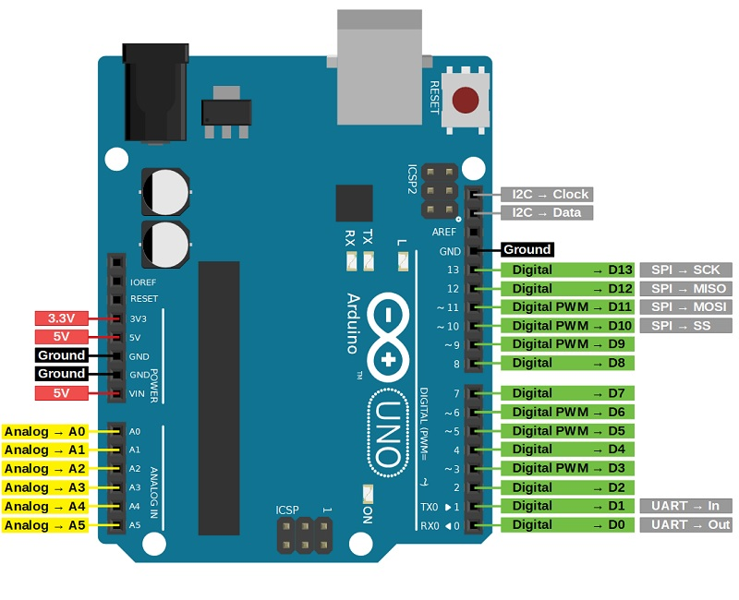
Figure 1.2.1: Arduino UNO Pin Diagram.

3
1.2.2 Colour Sensor
A color sensor is an electronic device that can detect and measure colors. It is commonly used in applications where color identification or differentiation is required. The color sensor works by analyzing the intensity and wavelength of light reflected from an object to determine its color. The color sensor typically consists of a light source, a photo-receiver, and a signal processing unit. The light source emits light onto the object, and the photoreceiver measures the reflected light. The signal processing unit then processes this data to determine the color of the object.

Color sensors are used in a wide range of industries and their
applications. They are commonly found in color sorting machines, automated quality control systems, printing devices, and even consumer electronics like smartphones and digital cameras. They enable precise color detection and ensure accurate color reproduction, enhancing the functionality and performance of various devices and systems.

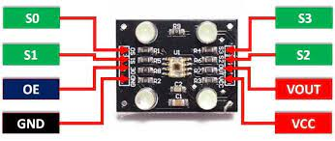
Figure 1.2.2: Colour Sensor Pin Diagram.

1.2.3 LCD Display and I2C Module
LCD is a widely used display technology that provides a visual output for various electronic devices. It consists of a grid of tiny cells (pixels) that can change their optical properties when an electric current is applied.It offer several advantages, including low power consumption, compact size, and versatility. They can be utilized in a wide range of devices, such as calculators, watches, smartphones, televisions, and computer monitors..
4

The LCD display sandwich structure typically includes two transparent general to
electrodes, with liquid crystal material placed in between. These electrodes apply an electric field to the liquid crystals, influencing their alignment and orientation.It can produce sharp, vibrant images with high contrast. They are capable of displaying text, numbers, graphics, and even videos. display multiple colors depends on the specific type of LCD technology used, such as TN (Twisted Nematic), IPS (In-Plane Switching), or OLED (Organic Light-Emitting Diode).It provide a user-friendly visual interface for interacting with electronic devices, enhancing the overall user experience..
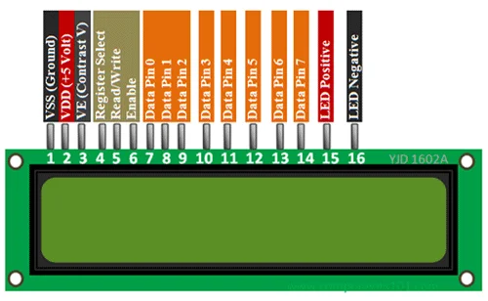 Figure 1.2.3: LCD Display Pin Diagram

The I2C (Inter-Integrated Circuit) module is a widely used communication protocol that facilitates serial communication between integrated circuits. It allows multiple devices to be connected using only two wires, making it ideal for applications where multiple devices need to exchange data efficiently. It consists of a master device (such as a microcontroller or a Raspberry Pi) and one or more slave devices. The master device initiates communication and controls the flow of data, while the slave devices respond to the commands and provide the requested data.
5

The two wires used for I2C communication are a clock
line (SCL) and a data line (SDA). The clock line generates clock pulses to synchronize data transfer, while the data line carries the actual data transmitted between devices.One of the key advantages of the I2C module is its ability to support multiple devices on the same bus. Each device on the bus has a unique address, allowing the master device to communicate with specific slaves individually.
The I2C protocol also supports different data transfer
modes, such as standard speed (up to 100 kHz), fast mode (up to 400 kHz), and high-speed mode (up to 3.4 MHz). This flexibility enables efficient data exchange in various applications, including sensors, EEPROMs, real-time clocks, and many other digital devices. Overall, the I2C module simplifies communication between devices using a minimal number of wires, making it a popular choice in many electronic systems

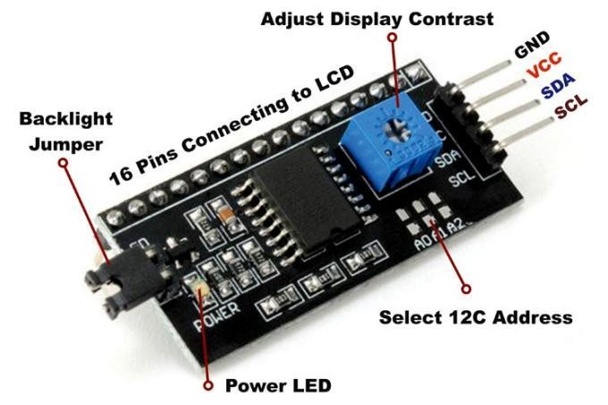

Figure 1.2.4: I2C Module Pin Diagram.

Applications
Industrial Applications
- Food Industry
Sorting fruits and vegetables (e.g., ripe vs. unripe tomatoes, green vs. red apples).
Removing discolored or spoiled items.
6
- Recycling Plants
Sorting plastics (e.g., clear vs. colored PET bottles).
Separating glass by color (green, brown, clear).
Identifying recyclable vs. non-recyclable items.

- Textile Industry
Sorting fabrics or garments based on color for quality control.
Identifying color defects during production.

- Pharmaceuticals
Sorting pills or capsules based on color to prevent packaging errors.
Ensuring consistency in product batches.

5. Manufacturing and Assembly Lines
Electronics: Sorting components (resistors, LEDs, capacitors) by color codes.

Automotive: Sorting colored wires or plastic parts during vehicle assembly.

Toy Manufacturing: Sorting pieces of different colors during packaging.

6. Packaging & Quality Control
Ensuring correct labeling or packaging based on product color.
Detecting foreign objects or defects by identifying off-color items.
Automatically sorting colored test tubes or chemical samples.
Identifying colored indicators in chemical reactions.

7
CHAPTER 2

LITERATURE SURVEY
R. Bogue in 2007 proposed of the paper titled "Optical chemical sensors for industrial applications", this study provides an overview of the development and use of optical chemical sensors across various industrial sectors. These sensors function by detecting the interaction of light with chemical substances to identify and quantify specific compounds. The paper outlines different types of sensors, including absorption-based sensors for detecting gases, fluorescence and phosphorescence sensors for monitoring oxygen and pH levels, and fiber optic sensors, which are especially useful for remote sensing in hazardous or inaccessible environments.

Timothy Henry in 2015 proposed of the paper titled “Design and Construction of Color Sensor Based Optical Sorting Machine”, this study describes the development of an automated sorting system that classifies objects based on color using optical sensing technology. The system integrates a color sensor (such as TCS230/TCS3200), a microcontroller for decision-making, and mechanical components like conveyor belts and actuators. As objects pass under the sensor, their color is detected, and corresponding sorting actions are executed via mechanisms like servos or flaps. The machine enhances sorting accuracy and efficiency in fields such as agriculture, recycling, and manufacturing, offering a cost-effective alternative to manual sorting.

Bozma and Yal-cin, proposed the paper title “Visual processing and classification items on a moving conveyor” this study explores the development of an automated sorting system that uses color sensing technology to classify and separate objects.
8
R. Mattone, G. Campagiorni, and F. Galati in 1999 proposed the paper titled “Sorting of Items on a Moving Conveyor Belt”, this study focuses on the automation of sorting processes for items transported on conveyor belts. The system utilizes sensors and control algorithms to identify and sort objects in real-time as they move along the belt. This approach enhances efficiency and accuracy in industrial applications, reducing the need for manual sorting and increasing overall productivity in sectors such as logistics, manufacturing, and packaging.

Md. Mostafizur Rahman Komol in 2019 proposed the
study titled “Design and Construction of Product Separating Conveyor Based on Color”, this work focuses on developing an automated conveyor system that classifies and separates products based on their color. Aimed at improving industrial automation, the system is particularly useful in sectors like packaging, manufacturing, and food processing, where rapid and accurate sorting is essential. By integrating color sensing with automated control mechanisms, the system enhances operational efficiency and reduces dependency on manual labor..

.

9

CHAPTER 3

METHODOLOGY

The color-based object sorting system operates using an Arduino microcontroller, a TCS3200 color sensor, a conveyor belt mechanism, and three servo motors. The conveyor belt is driven by a motor and is responsible for transporting objects one by one under the color sensor. The system begins by initializing the TCS3200 color sensor and attaching the servo motors to designated pins. As the conveyor belt moves, objects pass under the color sensor, which captures raw red, green, blue, and clear light intensity values. The system checks the clear channel value to determine if an object is present; if the value is below a predefined threshold, it assumes no object is present and continues. Once an object is detected, the system halts the conveyor belt momentarily to ensure stable color detection. It then analyzes the RGB values: if the red component is significantly greater than green and blue, the object is classified as red; similarly, dominant green or blue values identify green or blue objects respectively. The corresponding servo motor is then activated, rotating to 90 degrees to divert or push the object into the appropriate bin, then returning to the initial 0-degree position. After sorting, the system waits until the object is cleared from the sensor’s view by monitoring the clear channel value again, and the conveyor belt resumes to carry the next item. This integrated approach ensures accurate color identification, smooth object movement, and reliable automated sorting using a combination of sensor detection, conveyor motion control, and mechanical actuation.

10
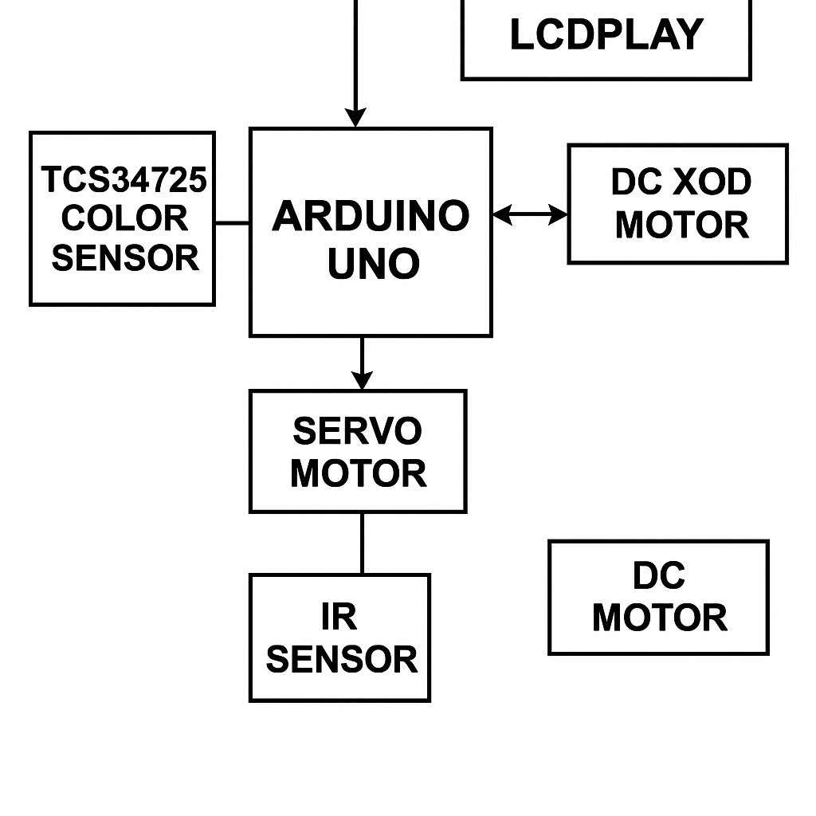
Figure 3.1: Block Diagram

3.1 Prototype Design Parameters
The proposed system is designed for automatic sorting of Red or Yellow or Blue colored products. The prototype consists of LCD Display with i2c module, Arduino UNO and Colour sensor TCS230 (Fig. 3).LCD Display is used to show the output which is input through the program. After integrating the programmed Arduino UNO and the TCS230 circuitry with the structure of the model, we measure the frequency of signals corresponding to each color by observing them on a Serialmonitor
Based on International Journal of Research and Innovations in Science and Technology Volume 2 : Issue 2 : 2015 this study the timer delay value is adjusted by reprogramming the Arduino UNO.This prototype is designed to used in library to arrange the book according to its colour so the colour sensor detect the colour and display that where the book has to be placed through LCD display. This prototype can also be used in sorting chemicals, goods, garbage and so on. Figure 3: prototype.

11
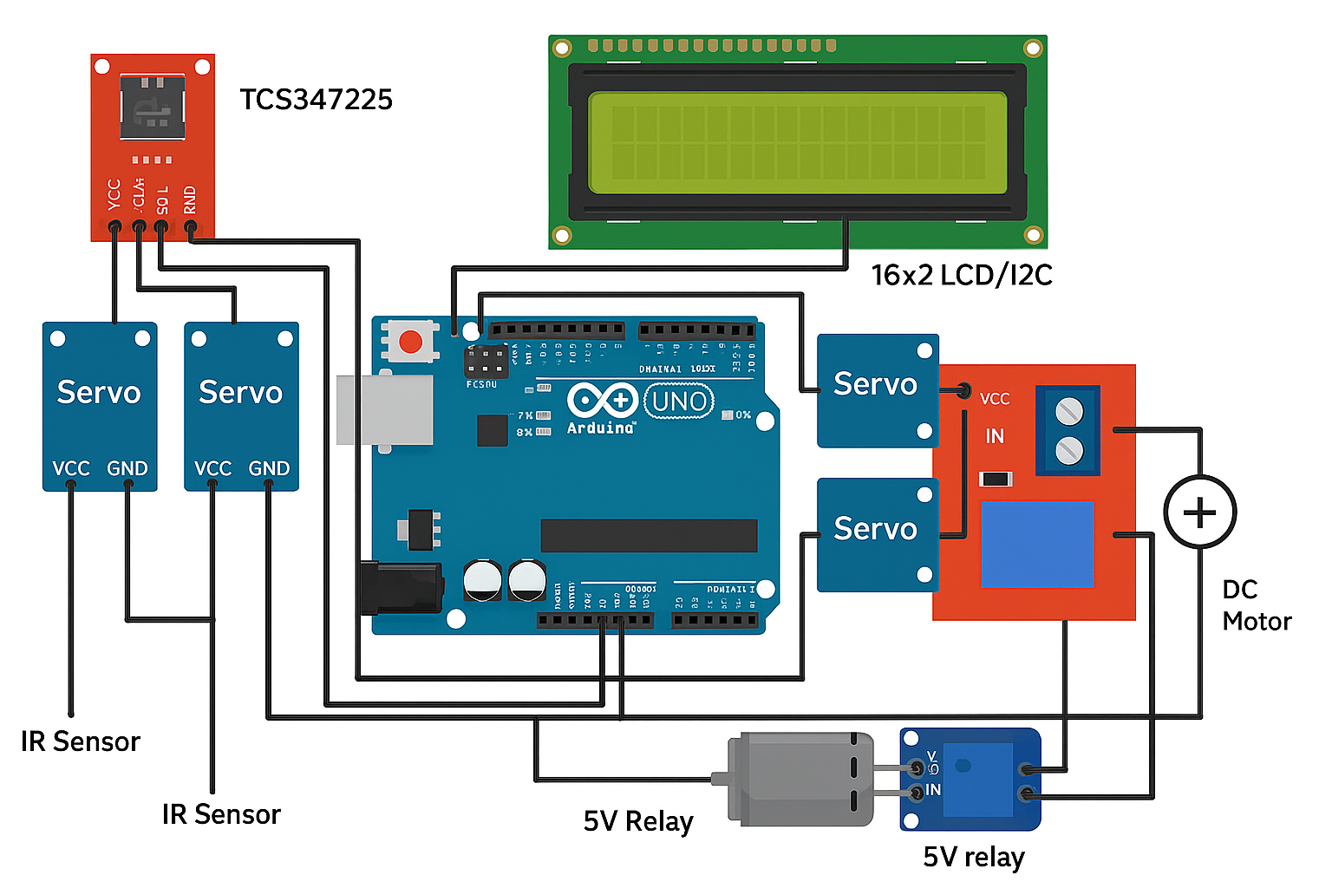
Figure 3.2: Circuit Diagram.

3.3 TCS230 Color Sensor

The TCS230 is a programmable color sensing module equipped with GY-31 light-to frequency converter that combines configurable 8x8 silicon photo-diode array as single monolithic CMOS integrated circuit [17]. The output is a square wave (50 percentage duty cycle) with frequency directly proportional to light intensity (irradiance). The full scale output frequency can be scaled by one of three preset values via two control input pins.
Digital inputs and digital output allow direct interface to a Arduino UNO or other logic circuitry. Output enable (OE) places the output in the high impedance state for multiple unit sharing of a Arduino UNO input line. The light-to-frequency converter reads an 8 x 8 array of photo-diodes.
Sixteen photo-diodes have blue filters, 16 photo-diodes have green filters, 16 photo-diodes have red filters, and 16 photo-diodes are clear with no filters. The four types (colors) of photo-diodes are inter digitalize to minimize the effect of non-uniformity of incident irradiance. All 16 photo-diodes of the same color are connected in parallel and which type of photo-diode the device uses during operation is pin select able. Photo-diodes are 120 mm x 120 mm in size and are on 144-mm.
12
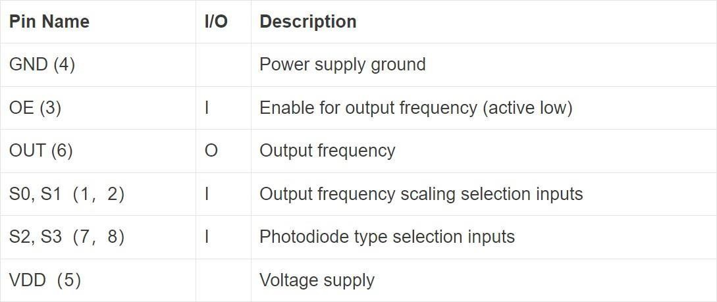

Table 3.1: TCS3200 Color Sensor Pin Out

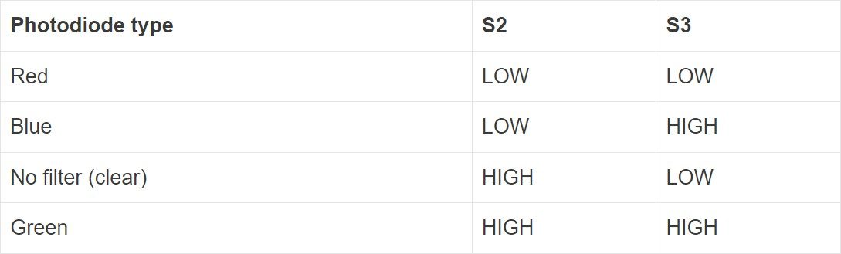

Table 3.2: Filter Selection

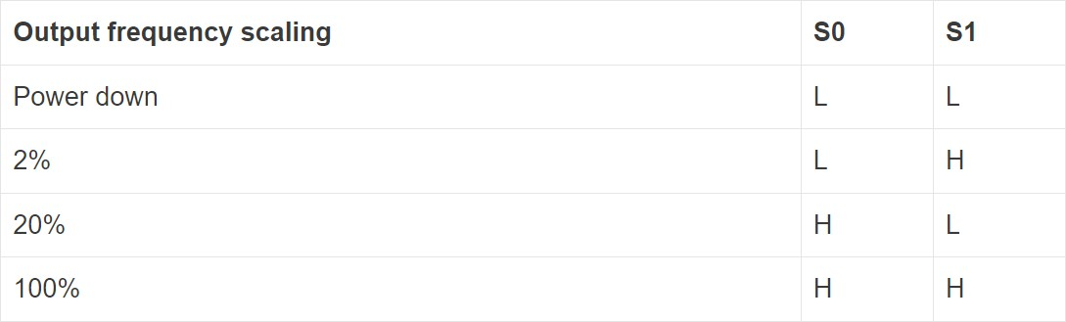

Table 3.3: Frequency Scaling

13
3.4 Constraints on Object Dimensions

The test objects were the books that has a colour paper are to be
pasted on its side according to its category. The distance between the top surface of the object and the color sensor, during the time of detection process, must always be the same. The reason for such a constraint is owed to the fact that TCS230 produces output signals of different frequencies while detecting the color of the same object kept at different distances from the sensor. In other words, deducting the height of our test object, the sensor and the top of the object is close to each other as showing the Figure 4.

3.5 Working of the model

When a supply of 5V is given to the the LCD Display and colour
sensor starts to work. When the light falls on the product it is reflected back to color sensor. As mentioned before, color sensor TCS230 has 4 color filters for green, red, blue and black (no color), which is opted by its select pins.

Filters are selected by the program saved in the Arduino UNO. Frequency output from color sensor depends on the color of the object as well as the select pin configuration input from Arduino UNO. Select pin can select one of the four photo diode filters which can give output according to the color of the object. When there is no object in front of sensor it produces an output of 330Hz range frequency and when there is an object it produces an output frequency of 7-14 kHz. International Journal of Research and Innovations in Science and Technology Volume 2 : Issue 2 : 2015

14

The Arduino UNO can find the frequency of the output from TCS230 by counting falling or rising edge of sensor given to its TOCK1 pin using pre-scalar settings set by option register configuration. The pre-scalar was set for 1:16 arrangement and the time for counting is 50ms. Hence Arduino UNO counts the frequency using its timer at the rate of one increment for sixteen falling edges of input frequency given to TOCK1.

When there is no object in front of sensor it produces an output of 330Hz range frequency. Hence we set a break down value of 32H for deciding whether there is an object on the conveyor belt or not. Therefore the PIC can only proceed to the next step after checking this condition. If there is an object the sensor produces an output frequency which is proportional to the color of the object and the selected photo diode configuration in such a way that it provides maximum frequency for the respective color to the respective photo diode.

Hence sensor gives maximum frequency for red colored object when
red filter is selected, and in the same way other colored object are also sensed by corresponding filters. Frequency received during each filter selection is counted and saved to separate registers and these values are examined for taking the greater one, in order to identify the color of the object. When the sensor detects the colour it gives the location of the book or object at which it has to be placed through the LCD Display. Fig.2 shows the circuit connections between different components of the model. The Arduino UNO, has 20 pins, out of which five pins are connected to TCS230 color sensor, and two pins are connected to LCD Display.

15

CHAPTER 4

RESULT AND DISCUSSION

We have developed a sorting machine using Arduino UNO for color sorting, taking in to consideration three colors namely Yellow, Red and Blue. We consumed two weeks to produce the prototype with the expense of Rs.2000. Fig.4 shows different stages involved in the process. You may note that the when different colour sensed the LCD Display show different location at which the object has to be placed

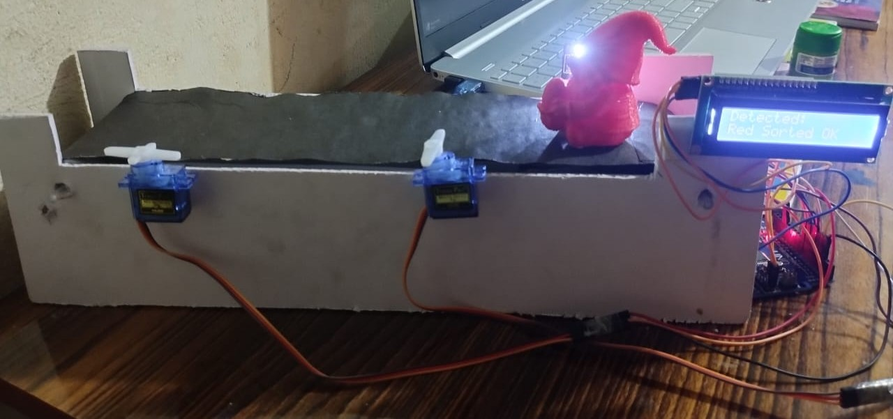

Figure 4.1: Prototype

16

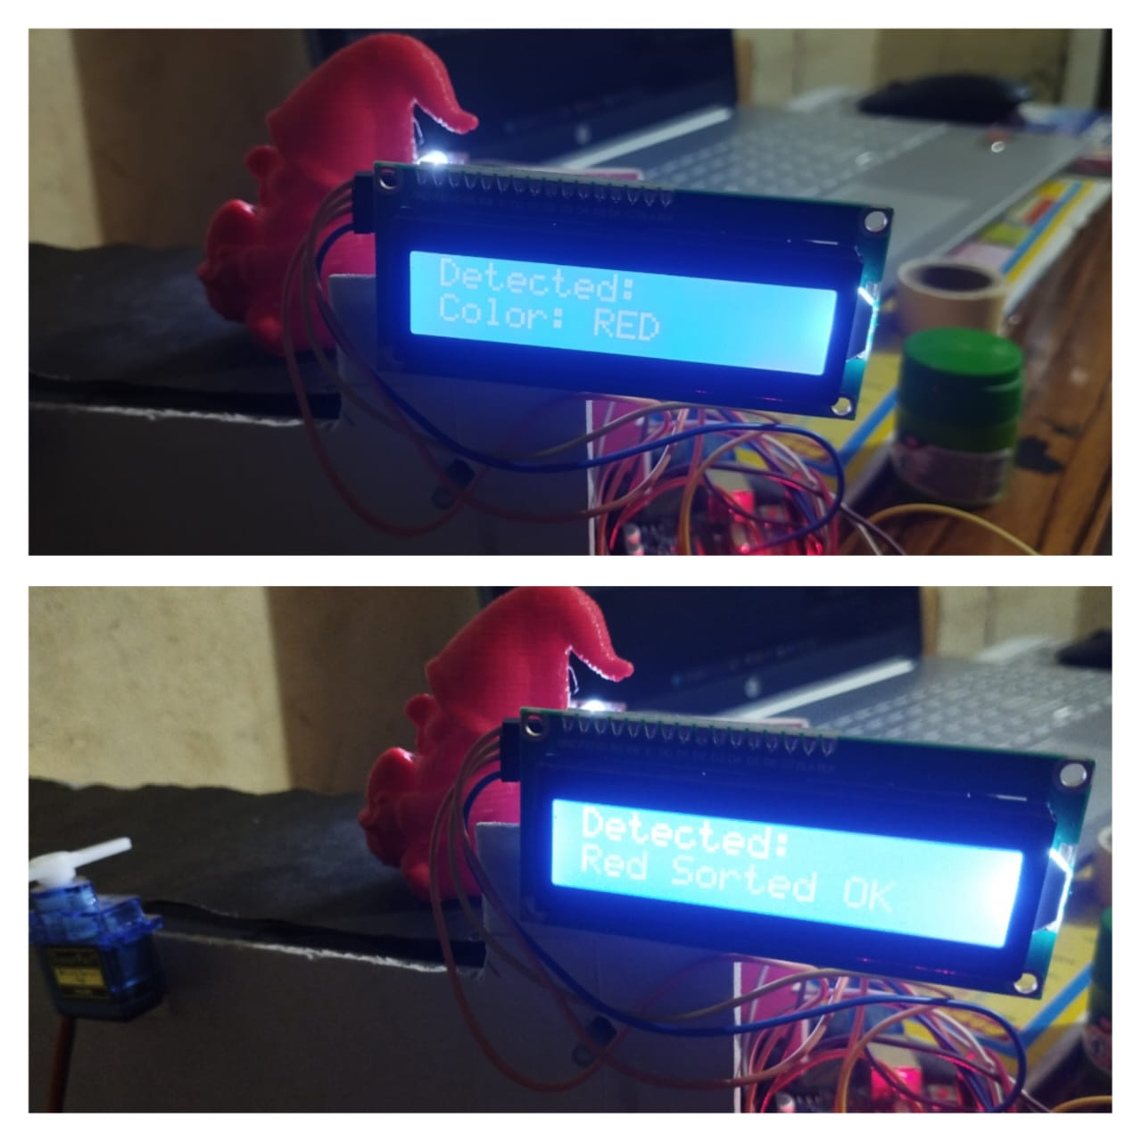

Figure 4.2: Detecting colour red and display the product is sorted

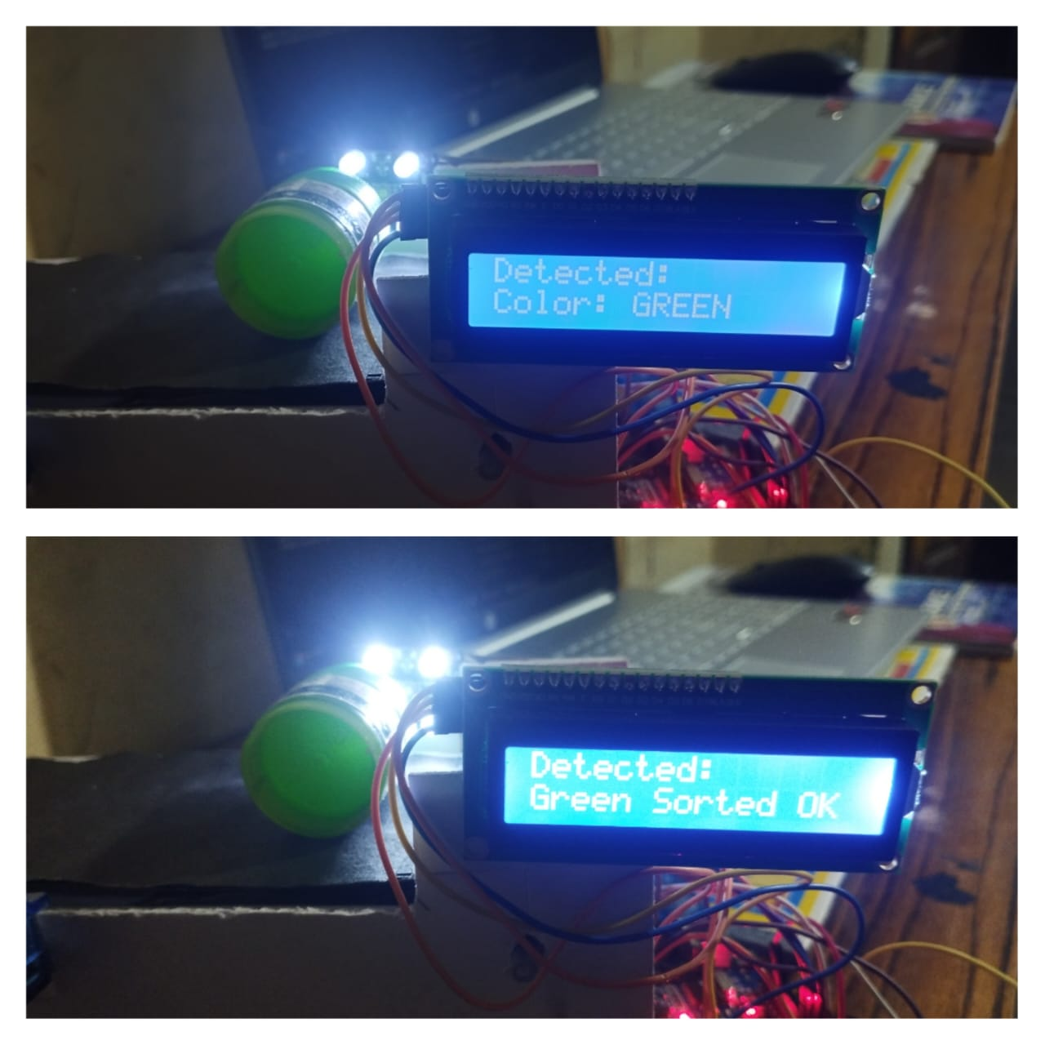

Figure 4.3: Detecting colour green and display the product is sorted

17

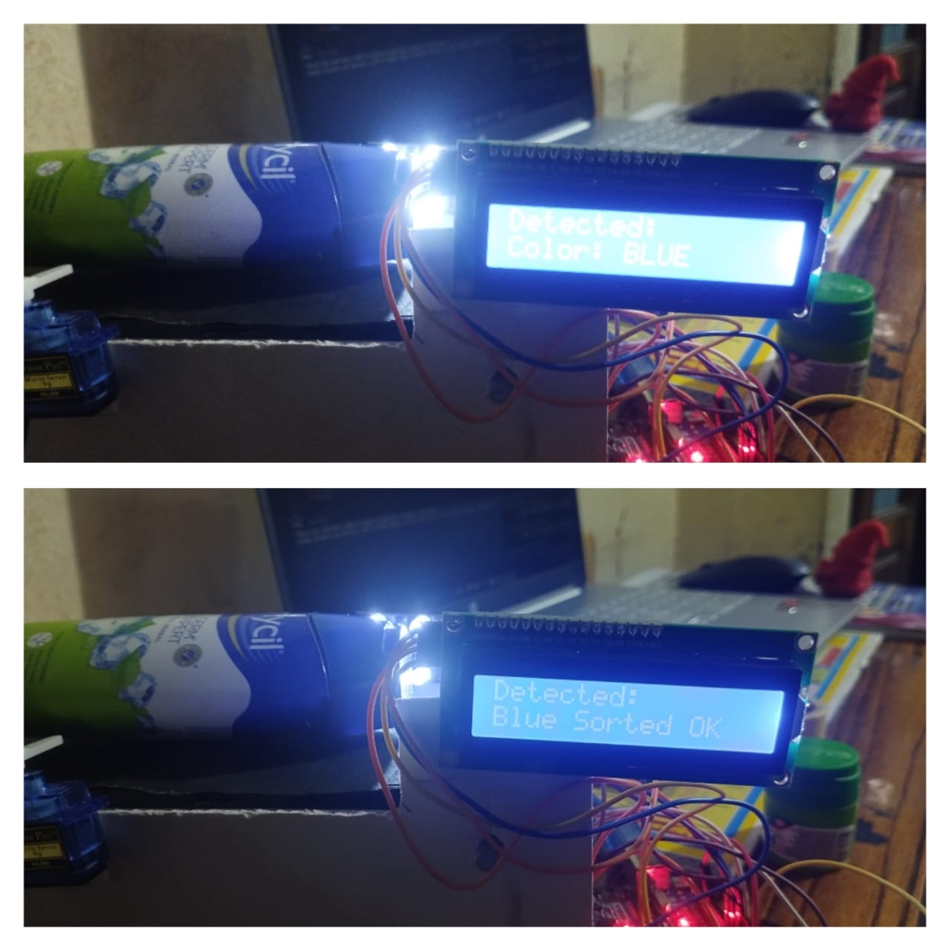

Figure 4.4: Detecting colour blue and display the product is sorted

18

CHAPTER 5

CONCLUSION

The color sorting system was successfully developed using the TCS3200 color sensor and two servo motors, controlled by an Arduino board. The sensor accurately detects the primary colors—red, green, and blue—based on light frequency values. Once a color is identified, the Arduino triggers the appropriate servo motor to sort the object into its designated position. One servo motor is dedicated to sorting green objects, while the second servo handles both red and blue objects by moving to specific angles for each color. The system also includes an I2C LCD display that shows the detected color and sorting status in real-time, enhancing user interaction. This project demonstrates a simple yet effective method for color-based object classification, offering a practical application in automation, recycling, and learning environments.

19

CHAPTER 6

FUTURE SCOPE

In the future, this color sorting system can be enhanced by incorporating additional sensors to detect a wider range of colors and improve accuracy. Using more servo motors or robotic arms could allow sorting of more colors, such as yellow and orange, or even multiple objects simultaneously for higher efficiency. Integrating wireless communication or IoT features would enable remote monitoring and control, making the system more versatile for industrial applications. Furthermore, implementing machine learning algorithms could improve color recognition under varying lighting conditions and object shapes, making the sorter more adaptive and reliable in real-world environments. Lastly, scaling up the system with conveyor belts and automatic object feeding mechanisms could transform this project into a fully automated sorting line.

20

REFRERENCES

- C. Zhang and K. S. Suslick, “Colorimetric sensor array for soft drinks analysis”, J. Agric Food Chem, vol 55, pp 237-242, 2007.

- P. D. Oram and J. Strine, “Color measurement of a solid active pharmaceutical ingredient as an aid to identifying key process parameters”, J. Pharm Biomed Anal, vol 40, pp 1021-1024, 2006.Author, Title of the Book, Publisher, (200X), pp:XXX-YYY.

- M. Frank, Nobert Kaiser, Wolfgang Buss, Ramona Eberhardt, “High- speed industrial color and position sensors”, Electronic Imaging’99, pp 50-57, 1999.

- A. Pacquit, J. Frisby, Danny Diamond, King Tong Lau, Alan Farrell, Brid Quilty, Dermot Diamond, “Development of a smart packaging for the monitoring of fish spoilage”, Food Chem, vol 102, pp 466-470, 2007.

- E. J. Cadieux Jr, “System and method for visually inspecting a cigarette packaging process”, ed: Google Patents, 2002.

[6] R. Bogue, “Optical chemical sensors for industrial applications”, 2007.

[7] Malathy Jawahar “Sensor based Color Sorting System for leathers
shoe components” 2017

[8] Timothy Henry “Design and Construction of Color Sensor Based
Optical Sorting Machine “ 2015

[9] Md. Mostafizur Rahman Komol “Design and Construction of Product
Separating Conveyor based on Color” 2019

[10] R Mattone, G. Campagiorni, F. Galati, “Sorting of items on a moving
conveyor belt”, 1999.

[11] H. Escid, et al., “0.35 mm CMOS optical sensor for an integrated for the
transimpedance circuit”, the International Journal on Smart Sensing and
Intelligent Systems, vol. 4, no. 3, pp. 467481, September 2011.

21

[12] Norfazlinda Binti Daud, ”Application of colors sensor in an automated
system”, Technical University Malaysia, May 2007.

[13] Bickman, Josh, “Automated Color-Sorting uses optical technology”,
vol.13, 1996.

[14] Bozma and Yal-cin, “Visual processing and classification of items
on a moving conveyor: a selective perception approach”, vol. 18, issue
2, 2002.

[15] C Boukouvalas, J Kittler, R Marik, M Mirmehdi and Petrou,
“Ceramic tile inspection for color and structural deffects”, University

22

